Join us this year in the MMS STEM/Science Club! We will be having fun learning the principles of STEM through a variety of challenges.
STEM/Science club will be sponsored by Mrs. Stephanie Virgin.
Meetings will be from 3-5 on the following dates. (Student who are picked up 10 min late are subject to having their membership revoked).
Meeting Dates
September 29 (2 hours 3-5)
October 27th (2 hours 3-5)
November 16th (2 hours 3-5)
December 15th (2 hours 3-5)
January 19th (2 hours 3-5)
February 16th (2 hours 3-5)
March 16th (2 hours 3-5)
Prepping for the Cardboard Boat Regatta @DPA
April 20th (2 hours 3-5)
April 27th (2 hours 3-5)
May 14th Cardboard Boat Regatta @DPA (TBA)

Club Dues
Club dues cover all meetings during the school year. There is no option to register for individual meetings.
Fee Amount: None this year, but this could change from year to year depending on supply needs.
Dues include all materials for activities. If specialized materials or transportation are required for a specific activity -- this is rare but possible, depending on the activities that club members choose -- there may be an additional charge for that specific activity. If an additional charge is necessary for a specific activity, club members and parents will receive advance notification.
Rules
- Students will be required to attend EVERY meeting. This will be a commitment!! If a situation occurs where the student is unable to attend a meeting, approval for absence will need to be given by club sponsors.

- Maintain a “C” average (probation period will be given)

- End of the year field trip – students who receive two detentions or an office referral will not be permitted to attend the end of the year trip.
Students are required to follow club rules to participate. Membership will be revoked if rules are not met.

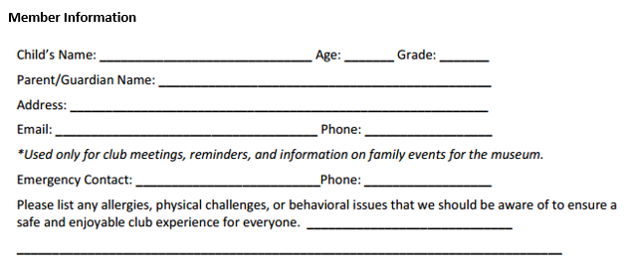
Guardian Consent
I give my consent for my child to participate in the MMS Science Club.
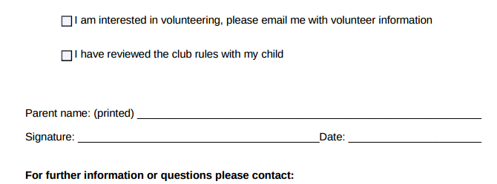
stephanie.virgin@wcsk12tn.net

